EVALUATION – 2

NAME: K.V.Sridhar Sai

Roll-No: CB.EN.U4CSE19063

Topics: class diagrams and sequence diagrams

Sequence diagram :



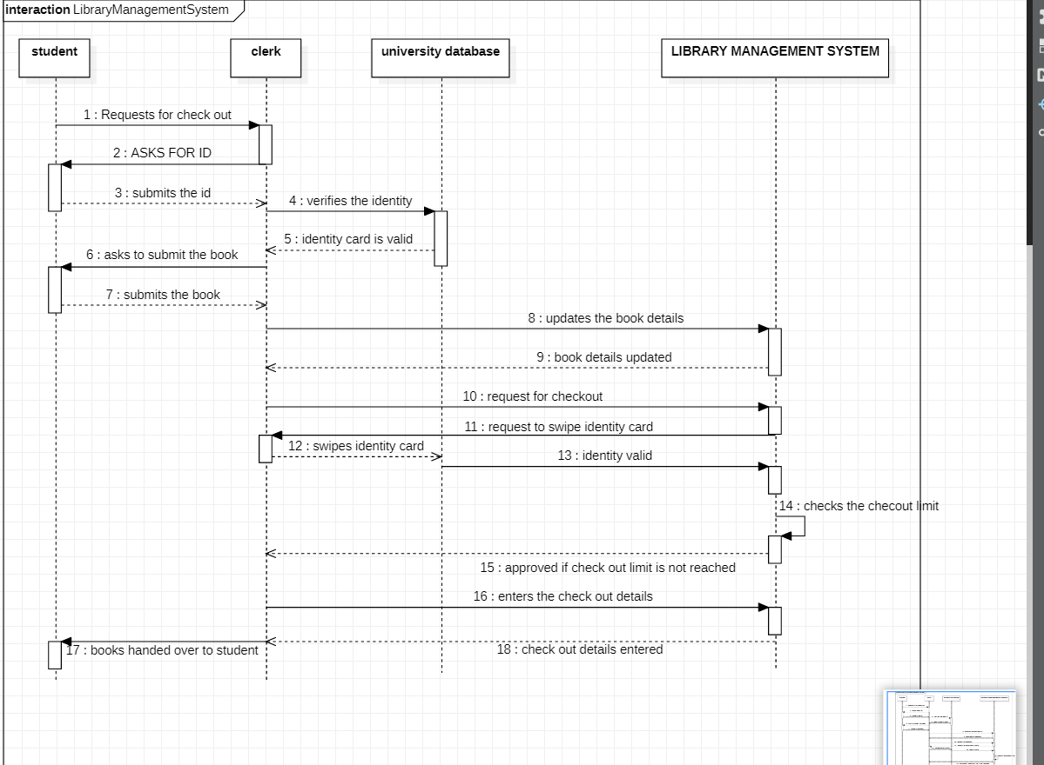

1. Class diagram:

